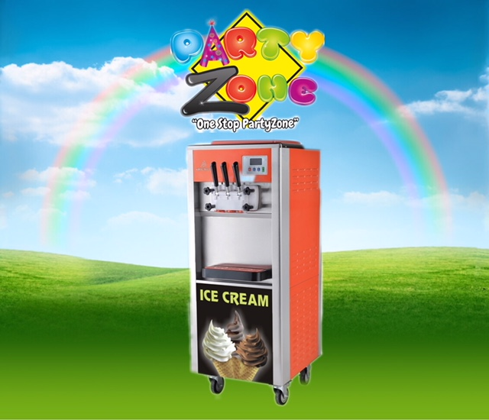



Thank you for renting an Ice Cream machine from PartyZone.ie. Please follow the directions below for to make delicious Ice cream for your event. If you have any questions or problems, please do not hesitate to contact us on 0852222000 or 0851568667.

**PLEASE READ ALL INSTRUCTIONS BEFORE USE**

**PRECAUTIONS**

Carefully read all instructions before operation.

Do NOT immerse any part of this equipment in water.

Keep cord and plug off the ground and away from moisture. Always unplug the equipment before cleaning.

To avoid burns, do NOT touch heated surfaces.

Do NOT place or leave objects in contact with heated surfaces.

Do NOT allow direct contact of this equipment by the public, this machine is NOT to be operated by anyone under the age of 18.

**Ice Cream Pannel Settings and Functions**

1. **Cleaning Key**
   1. Understand-by mode, press “cleaning” key to enter the cleaning mode: the cleaning indicator lamp will be on, the buzzer will beep once, the stirring motor will start running and LCD will show present current value of stirring motor. Press cleaning key again to return to stand-by mode.
2. **Refrigeration Key**
   1. Understand-by mode, press “refrigeration” key to enter refrigeration mode: The refrigeration indicator lamp will be on; the buzzer will beep once; the stirring motor, compressor, fan motor will start running and LCD will show present current value of stirring motor.
3. **Puffing Key**
   1. Understand by mode, press “puffing” key: the air pump indicator lamp will be on but the air pump will not world; Under cleaning or refrigeration mode, press puffing key: air pump indicator will flash, and air pump will start running.
4. **Hardness Adjustment Key**
   1. **Under refrigeration mode, press the up arrow or down arrow key to adjust the hardness of the ice cream. Press the up arrow key once, the hardness will increase by 0.1. Press the down arrow key, the hardness will decrease 0.1. The bigger the hardness value is the softer the ice cream becomes**
5. **Showing of Quantity of Ice Cream:**

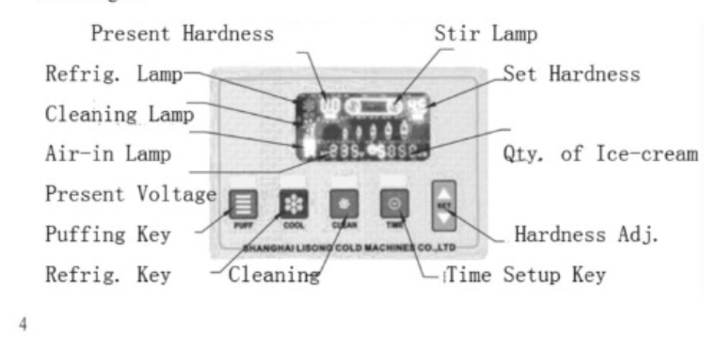

**How to Make Ice Cream**

1. Leave the prepared Ice-cream slurry standing for 15 minuites before pouring it into the two cylinders on the top of the ice cream maker.
2. Connect power supply to let the ice cream maker enter stand-by mode. Press “cleaning Key”, to let the machine run for three to five minutes. At this time, hold down the handle to let the slurry be discharged for two to three cups before pouring them back into the upper slurry cylinder in order to prevent freezing of water in the discharge opening.
3. Press “refrigeration” key and the machine enters refrigeration mode: Press the up-arrow and down-arrow keys to attain the desired hardness of ice cream.
4. When the hardness of ice cream reaches the setup hardness value, the machine will stop running and stand-by automatically; The automatic re-start time after the machine stops and stands by may be varied within the range of three to nine minutes. At this time, you may press the time adjust key to set the duration before the next refrigeration cycle starts. Press the key once, the time will increase by one minute until nine minutes. When reaching nine minutes, the system will return to three minutes by pressing the key again.
5. Place a cone or a cup under the outlet of discharging valve and hold down the discharging handle to squeeze out ice-cream. Release the handle to clo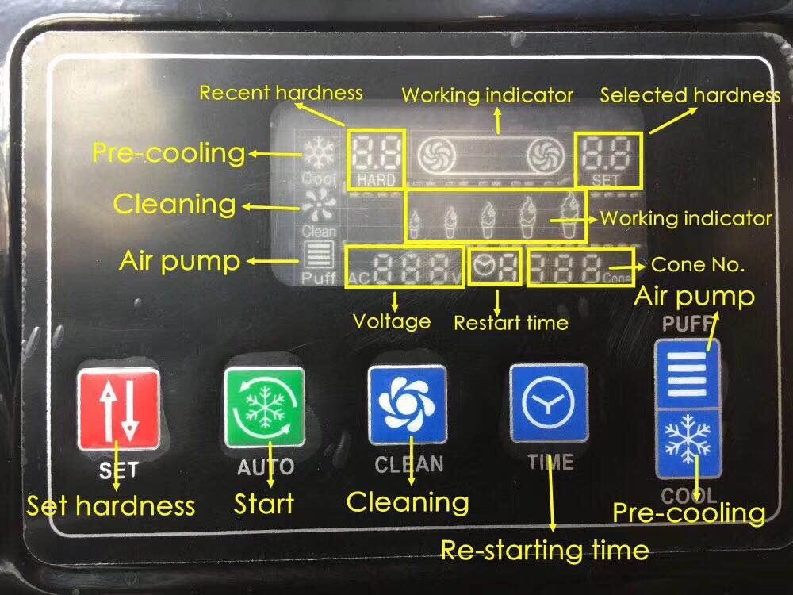

**Cleaning and Maintenance of the Maker**

* 1. **Cleaning of refrigeration cylinder.**

When the ice-cream maker is going to be put idle, the refrigeration cylinder shall be cleaned and sterilized, so as to guarantee the health of ice-cream consumers and extend the service life of components.

* + - Press cleaning key to discharge all the creams inside the cylinder followed by pressing the key again to stop the machine.
    - Add hot water and proper amount of disinfection lotion into the cylinder.
    - Press cleaning key to stir for about 5 minutes before discharging the cleaning liquid.
    - Repeat the cleaning procedure with hot water for 2-3 times. Stop the machine.
    - Turn off the power supply. Disassemble the components for cleaning:
      * Remove the four nuts on the side of the outlet valve to takedown the outlet valve assembly. Take out various parts of the outlet valve assembly in turns: handle pin, handle, valve rod, seal ring. Take out the stirrer from the refrigeration cylinder. Clean all the disassembled parts. Replace it with a new one in case of any damage occurring. Re-assemble all the parts in reverse order.

2. **Cleaning of body**

* In order to ensure the cleanliness, tidiness, and beauty of the maker, you are suggested to wipe the body with a lukewarm towel to remove dirt. Be sure not to rinse with water, which may lead to malfunctioning.

**NOTES**

Any other queries please do not hesitate to contact

085-2222000 or 0851020175