**POPCORN MACHINE POPPER/WARMER**

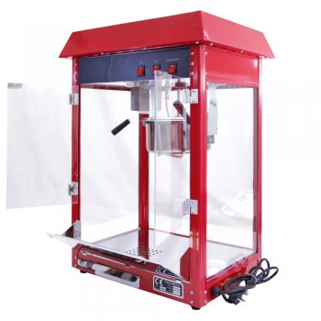

**Operating Manual**

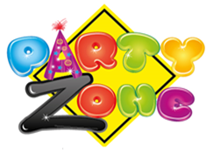

Thank you for renting a popcorn machine from PartyZone.ie. Please follow the directions below for to make delicious popcorn for your event. If you have any questions or problems, please do not hesitate to contact us at 0852222000 or 0851568667.

**PLEASE READ ALL INSTRUCTIONS BEFORE USE**



**PRECAUTIONS**

Carefully read all instructions before operation.

Do NOT immerse any part of this equipment in water.

Keep cord and plug off the ground and away from moisture. Always unplug the equipment before cleaning.

To avoid burns, do NOT touch heated surfaces.

Do NOT place or leave objects in contact with heated surfaces.

Do NOT allow direct contact of this equipment by the public, this machine is NOT to be operated by anyone under the age of 18.

**Electrical Specifications:**

**1000 Watts, 240V 50HZ., 13AMP Plug**

**Make sure to plug in to a dedicated line with the specifications above and that no other appliances are on the same circuit.**

**Pre-Popped Popcorn Machine Operation Instructions (Customer without server option)**

Plug in machine at source.

Push kettle lid up to the top of cabinet where a magnet will hold it in place. The kettle will not be in use when Pre-popped popcorn is used.

Immediately add the popcorn. (DO NOT OVERFILL: only ½ pack of popcorn pack at a time)

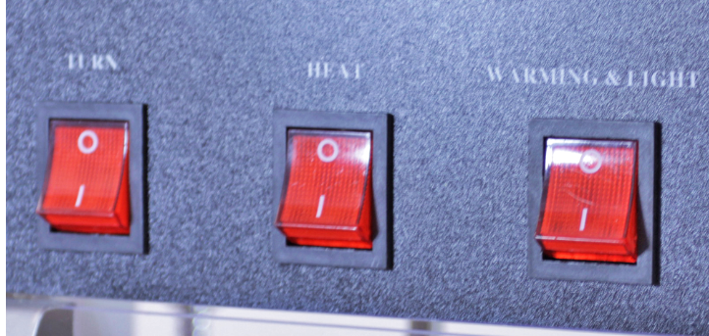

Turn “WARMING & LIGHT” switch to ON (I)

Ensure that other switched “TURN” + “HEAT” are in the **OFF** (0) position

(Wait 3-4 minutes for unit to heat up).

Close all trays and doors to keep in the heat.

Stir every 3 mins to allow mixture of popcorn to bottom element heater to be as efficient when heating this will speed up the process of the warmer.

**Note:** the light also warms popcorn from the top .

**Important Precautions:**

Always have the kettle motor switch OFF when not popping corn.

The kettle will get very hot! USE CAUTION ALWAYS.

Water must NEVER be put on the popping KETTLE!

Never lift machine from yellow top section. Machine weighs 75 pounds and it must be lifted from the base by at least 2 persons. Damage to machine will be billed at replacement cost.

With Server Option

**(STRICTLY ONLY TO BE USED BY PARTYZONE STAFF)**

When ready to add oil and popcorn, turn KETTLE MOTOR switch ON to start the motor.

Open the oil pouch and pour into the kettle.

Pull the kettle lid downward from the top of the cabinet to cover the kettle. DO NOT FORGET TO COVER THE KETTLE OR THE OIL AND POPCORN WILL IMMEDIATELY SPRAY OUT ALL OVER THE SIDES OF THE MACHINE.

While the corn is popping open the plexiglass doors slightly to prevent fogging.

Popcorn will pop quickly, and when the popping ceases, TURN BOTH THE KETTLE HEAT AND MOTOR SWITCH OFF.

Lift the kettle lid until it attaches to the magnet on top of machine. Dump popped corn by releasing the kettle, rotating the black handle clockwise and pulling downward.

Put the kettle back in place using the black handle to hook the kettle to the holding bolt. USE CAUTION - THE KETTLE IS VERY HOT!

If you are making several batches continuously you do not have to wait for machine to reheat. It will already be pre-heated.

**Remember to turn HEATING LIGHT SWITCH to ON in order to keep your popcorn warm.**

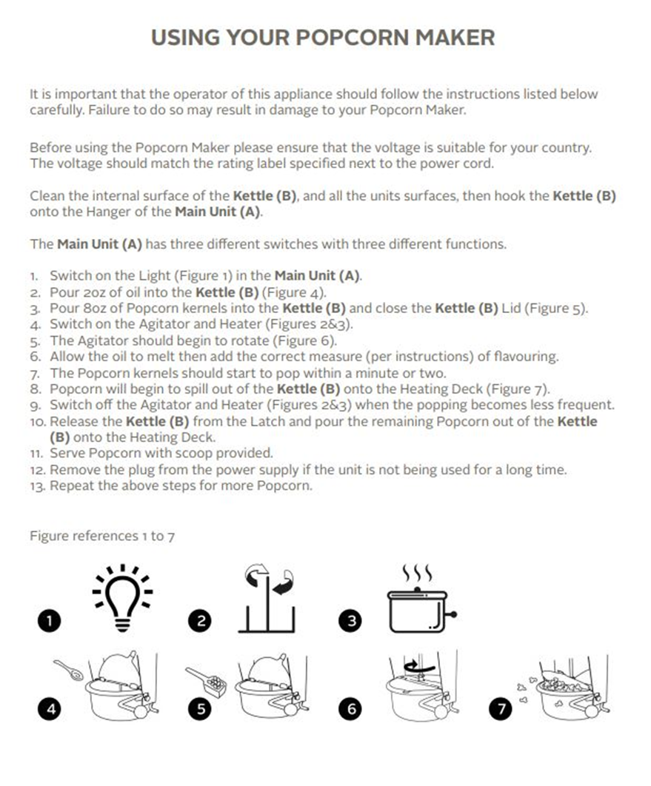

**Cleaning Machine**

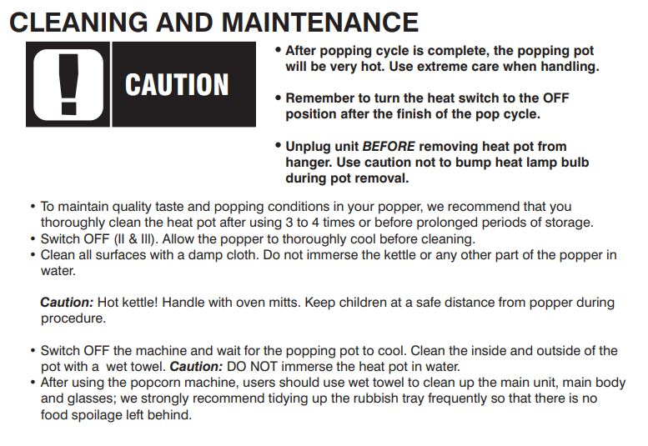

Wait at least one hour until the kettle has completely cooled. The kettle can be very hot - USE CAUTION.

Wipe all oil off the inside and outside of the kettle with a DRY clean soft cloth. NEVER PUT WATER ON THE KETTLE!!

**Popcorn machine must be returned clean.** **There is an additional €20 cleaning charge for machines that have not been wiped down or emptied.**

**NOTES**

Any other queries please do not hesitate to contact

085-2222000 or 0851020175

See youtube video for any more queries:

<https://www.youtube.com/watch?v=IbYLfdi9_GI>