**Kukoo CANDY FLOSS MACHINE**

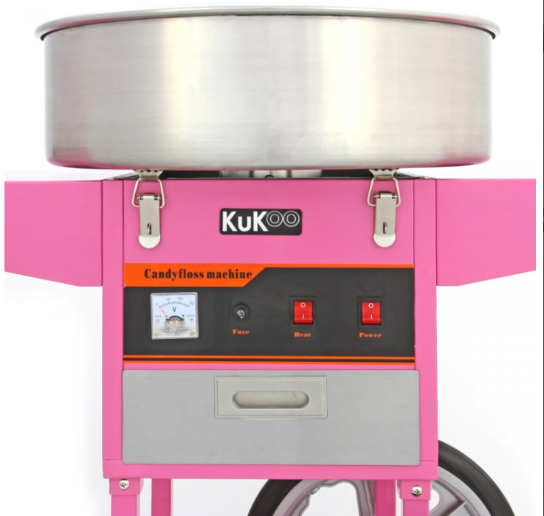

**OPERATING MANUAL**

Thank you for renting our CandyFloss machine from PartyZone.ie. Please follow the directions below for to make delicious Candy Floss for your event. If you have any questions or problems, please do not hesitate to contact us at 0852222000 or 0851568667.

**PLEASE READ ALL INSTRUCTIONS BEFORE USE**



**PRECAUTIONS**

Carefully read all instructions before operation.

Do NOT immerse any part of this equipment in water.

Keep cord and plug off the ground and away from moisture. Always unplug the equipment before cleaning.

To avoid burns, do NOT touch heated surfaces.

Do NOT place or leave objects in contact with heated surfaces.

Do NOT allow direct contact of this equipment by the public, this machine is NOT to be operated by anyone under the age of 18.

**Electrical Specifications:**

**1000 Watts, 240V 50HZ., 13AMP Plug**

**Make sure to plug in to a dedicated line with the specifications above and that no other appliances are on the same circuit**

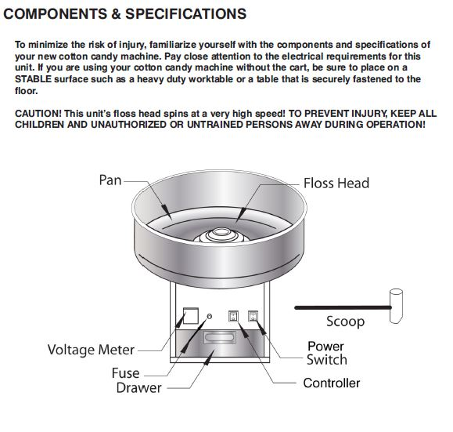

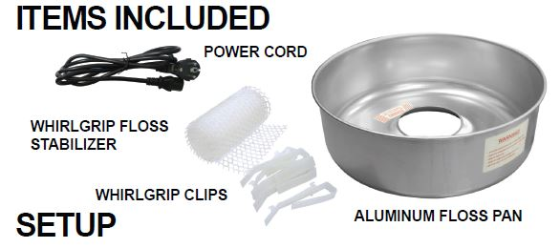

**CandyFloss Machine Operating Instructions**

The Cotton Candy Machine is easy to operate. Please review the operating instructions prior to use and follow instructions before operating the machine. Please follow the directions below to make cotton candy for your event. If you have any questions or problems, please contact us at 0852222000/ 0851568667. We hope you enjoy the Cotton Candy Machine!  
**Safety tips.**

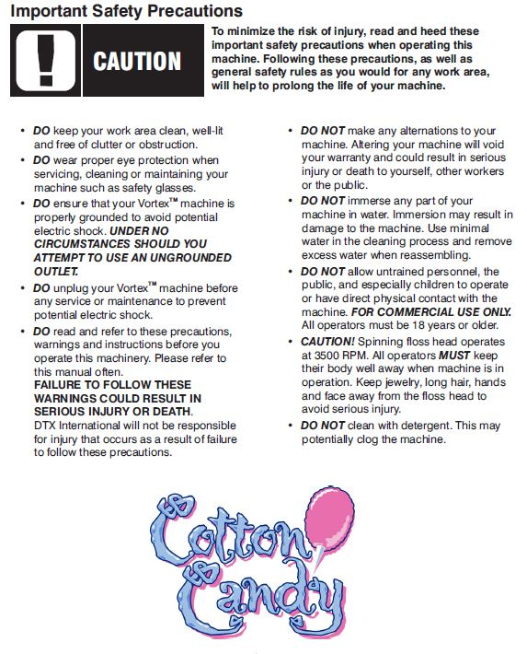

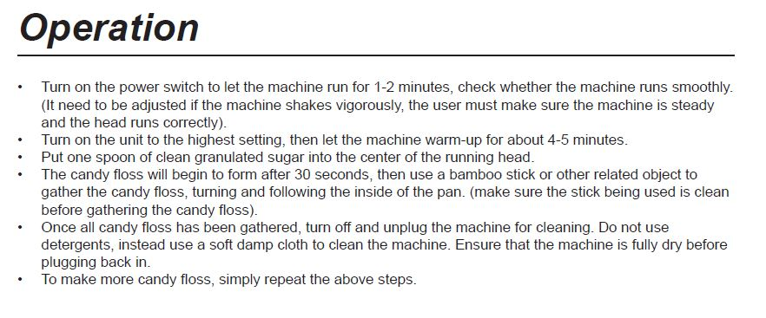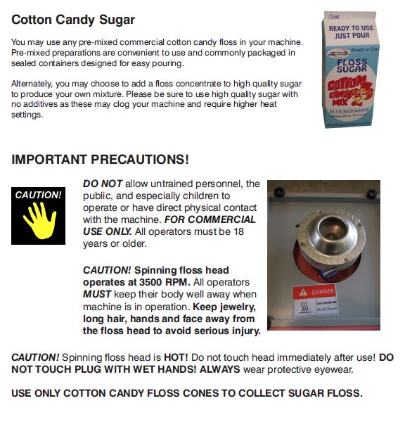

**Setup.**

* Place the rented cotton candy machine on a stable, level surface, such as a table or counter. Please keep the cotton candy machine upright at all times.To create a more attractive setting, rent a cart, stand or cabinet specially designed for the cotton candy machine.
* Make sure to set up the rented cotton candy machine near a grounded, electrical source, so that you will not need to use an extension cord, unless approved by the manufacturer of the rented cotton candy machine.
* Inspect rented cotton candy machine to ensure all parts are in place and that it is not in the transportation mode

Operators need to keep hands and face clear of floss head. Spectators must stand a reasonable distance away to be safe

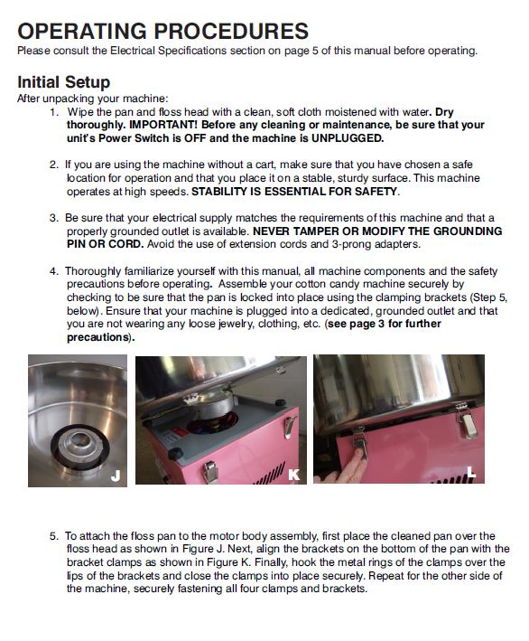

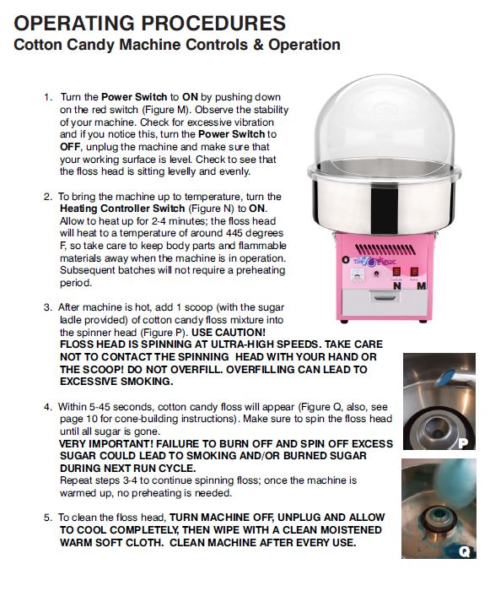

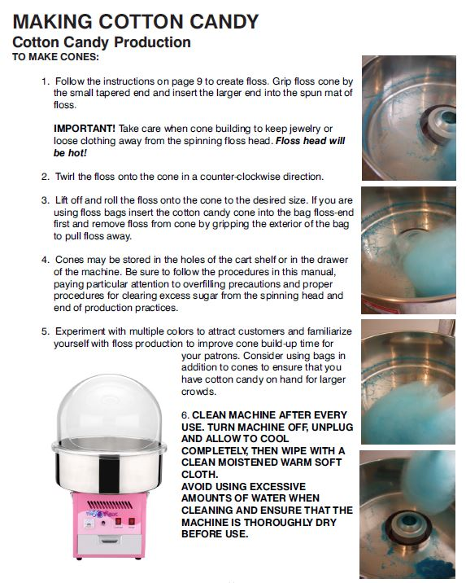

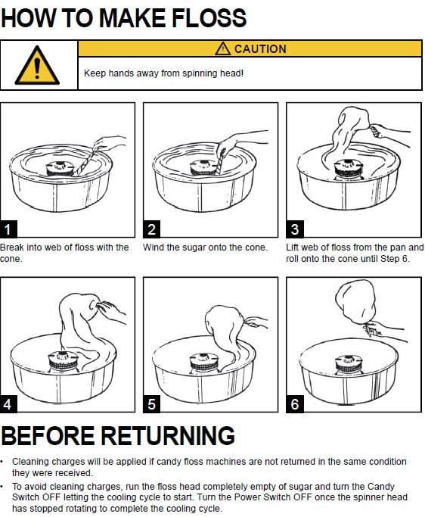

**Cleaning Instructions.**

Clean the rented cotton candy machine if you do not plan to use it again for several hours or are finished with the unit.

* Run all of the sugar out of the floss head on the rented cotton candy machine.
* Turn on heating element of the cotton candy machine for about a minute to remove any remaining sugar.
* When all sugar seems to be removed please add some water to the spinning head without heat on from a bottle of water small amounts at a time.
* This will remove any sugar stuck in machine and disperse it into the bowl in liquid format
* Unplug the rented cotton candy machine and wait for the machine to cool down.
* Ensure machine has cooled down before using a damp cloth to wipe floss head on candy machine. Do not immerse floss head in water or place it under running water.
* Clean the stainless steel bowl with hot water and Dry machine thoroughly.

**There is an additional €20 cleaning charge for machines that have not been wiped down or emptied.**

**Please See Video here for Instructions**

<https://www.youtube.com/watch?v=dsuf7lt26Cg>

**NOTES**

Any other queries please do not hesitate to contact

085-2222000 or 0851020175

www.PartyZone.ie