Klarstein Sweet Sundae Ice Cream machine

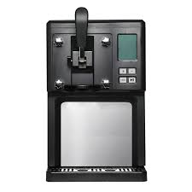


Thank you for renting a Ice Cream machine from PartyZone.ie. Please follow the directions below for to make delicious Ice cream for your event. If you have any questions or problems, please do not hesitate to contact us at 0852222000 or 0851568667.

PLEASE READ ALL INSTRUCTIONS BEFORE USE


PRECAUTIONS
Carefully read all instructions before operation.
Do NOT immerse any part of this equipment in water.
Keep cord and plug off the ground and away from moisture. Always unplug the equipment before cleaning.
To avoid burns, do NOT touch heated surfaces.
Do NOT place or leave objects in contact with heated surfaces.
Do NOT allow direct contact of this equipment by the public, this machine is NOT to be operated by anyone under the age of 18.

Safety Instructions
- Read all the safety and operating instructions carefully and retain them for future reference.
- Ensure the voltage is compliant with the voltage range stated on the rating label and ensure the earthing of the socket is in good condition.
- If the supply cord is damaged, it must be replaced by the manufacturer or its service agent or a similarly qualified person in order to avoid a hazard.
- Do not upend this product or incline it over a 45° angle.
- To protect against risk of electric shock, do not pour water on cord, plug and ventilation, immerse the appliance in water or any other liquid.
- Unplug the appliance after using or before cleaning.
- Keep the appliance 8 cm from other objects to ensure the good heat releasing.
- Do not use the accessories which are not recommended by Manufacturer.
- This device may be only used by children 8 years old or older and persons with limited physical, sensory and mental capabilities and / or lack of experience and knowledge, provided that they have been instructed in use of the device by a responsible person who understands the associated risks.
- Do not use the appliance close by flames, hot plates or stoves.
- Do not switch on the power button frequently (ensure 5 min. interval at least) to avoid the damage of compressor.
- Metal sheet or other electric objects are not allowed to be inserted into the appliance to avoid fire and short circuit.
- When take out the ice cream, do not knock the barrel or edge of barrel to protect he barrel from damage.
- Do not switch on the power before install well the barrel or blender blade.
- The initial temperature of the ingredients is 25±5°C. Do not put the ingredients into freezer for pre-freeze, as it will easily make the blender blade blocked before the ice cream is in good condition.
- Do not remove the blender blade when the appliance is on working.
- Do not use outdoors.
- Never clean with scouring powders or hard implements.
- Do not store explosive substances such as aerosol cans with a flammable propellant n this appliance.
- This appliance is intended to be used in household and similar applications.
Special Notes
- When positioning the unit, make sure that the power cord is not pinched or damaged.
- Make sure that there are no multiple sockets or power supplies on the back of the unit. To avoid contamination of food, please follow the instructions below:
- Regularly clean surfaces that may come into contact with food.
General Instructions for Making Ice Cream
The ice cream can be prepared according to an individual recipe or according to
the recipe enclosed (see chapter Ice Cream Recipes). It is not necessary to freeze the ingredients in the freezer beforehand. The machine‘s built-in compressor can freeze the ingredients directly and process them into ice cream.
- Install the mixing fan blade on the drive shaft bore.
- The handle assembly is pre-installed.
- Pour the appropriate amount of evenly mixed ice cream ingredients into the funnel.
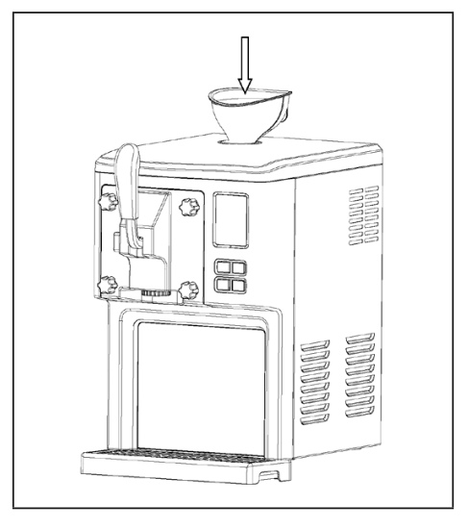
- Remove the funnel and insert the plug into the hole.
- Press the ON/OFF switch on the back of the unit.
- The machine starts to prepare ice cream. You can add more spices during the production process, but you should avoid adding granular materials to avoid clogging the openings.
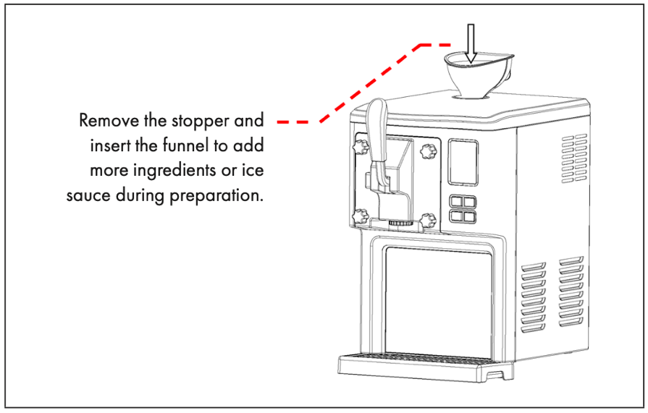
- When the ice cream is ready, a beep sounds. Pull the handle to remove the ice cream.
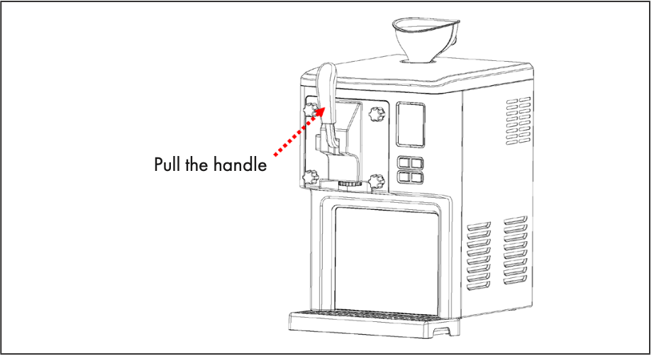
- Once you have removed the ice cream, you can prepare more ice cream.
NOTES
Any other queries please do not hesitate to contact
085-2222000 or 0851020175

