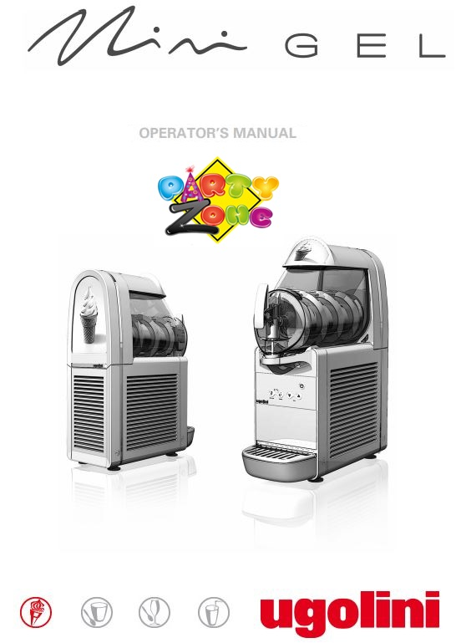

Thank you for renting a Ice Cream machine from PartyZone.ie. Please follow the directions below for to make delicious Ice cream for your event. If you have any questions or problems, please do not hesitate to contact us at 0852222000 or 0851568667.

**PLEASE READ ALL INSTRUCTIONS BEFORE USE**



**PRECAUTIONS**

Carefully read all instructions before operation.

Do NOT immerse any part of this equipment in water.

Keep cord and plug off the ground and away from moisture. Always unplug the equipment before cleaning.

To avoid burns, do NOT touch heated surfaces.

Do NOT place or leave objects in contact with heated surfaces.

Do NOT allow direct contact of this equipment by the public, this machine is NOT to be operated by anyone under the age of 18.

**Electrical Specifications:**

**1000 Watts, 240V 50HZ., 13AMP Plug**

**Make sure to plug in to a dedicated line with the specifications above and that no other appliances are on the same circuit.**

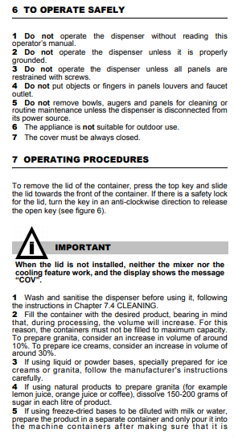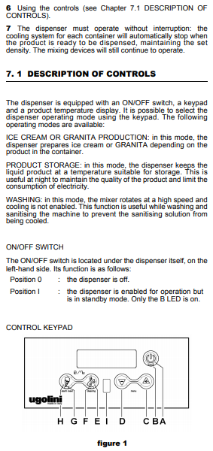

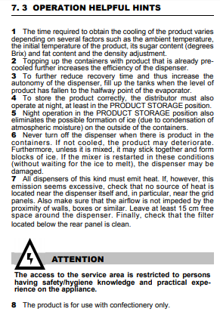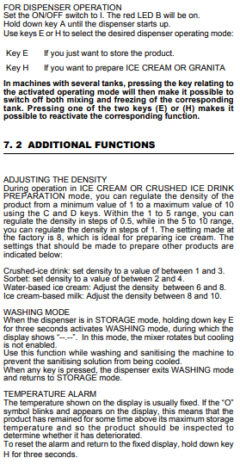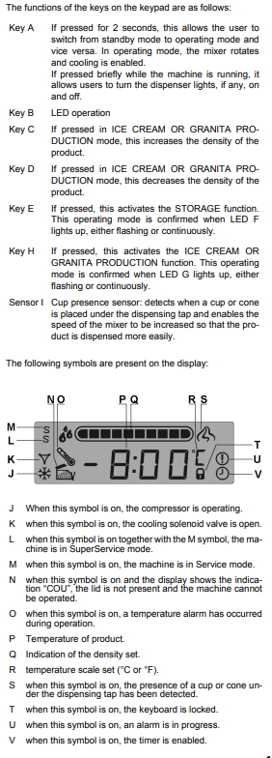

**Cleaning Instructions**

**1.)** When finished with the machine please ensure that all product has been dispensed from the machine, this can be done by releasing product from the handled nozzle until no further product will come out.

**2.)** Once this is complete there will be small pieces of product remaining in the machine these must be rinsed out using cold or luke warm water to remove any solution from the bottom containers. First see **below** disassemble step 1 to remove the top Lid to add the water

**3.)**Then repeat step 1 to remove all water from the machine.

**4.)** Next thing to thoroughly clean the tank and any stains we have remove the tank from the machine please follow before instructions carefully to do so.

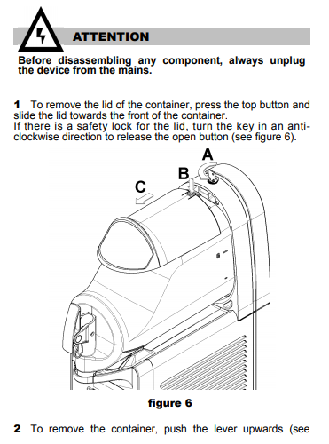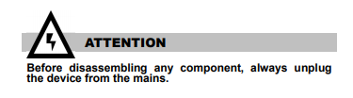

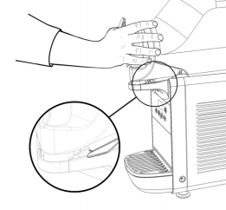

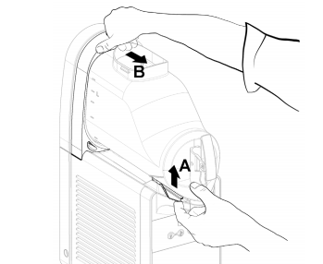

2. Release the white clip circled above by clipping it down

3. To remove the container push the lever (A) upwards and then Push from back of the tank at point (B) to release

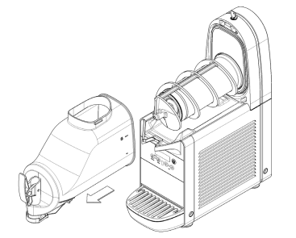

4.Remove tank to access spinning auger to clean tank and stainless steel freezer.

See A below to remove auger to access freezer and give through clean

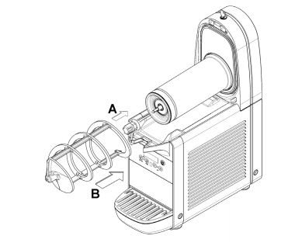

Clean tank with warm water and dry all off with dry towel/cloth.

See B to input auger back in once cleaned and put tank back and lid to close and wipe outside were necessary and await collection from driver.

**There is an additional €20 cleaning charge for machines that have not been wiped down or emptied.**

See below links for any further questions:

<https://www.youtube.com/watch?v=Pr-himDj4I4>

<https://www.youtube.com/watch?v=eq7DJ4-KqjI>

**NOTES**

Any other queries please do not hesitate to contact

085-2222000 or 0851020175