HOTDOG STEAMER/BUN WARMER

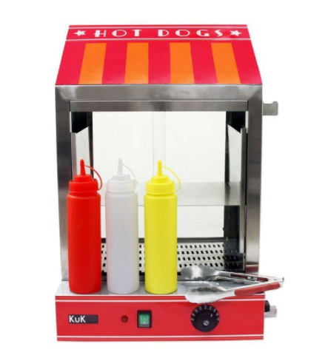

**Operating Manual**



**PLEASE READ ALL INSTRUCTIONS BEFORE USE**



**PRECAUTIONS**

Carefully read all instructions before operation.

Do NOT immerse any part of this equipment in water.

Keep cord and plug off the ground and away from moisture. Always unplug the equipment before cleaning.

To avoid burns, do NOT touch heated surfaces.

Do NOT place or leave objects in contact with heated surfaces.

Do NOT allow direct contact of this equipment by the public, this machine is NOT to be operated by anyone under the age of 18.

**Electrical Specifications:**

**1000 Watts, 240V 50HZ., 13AMP Plug**

**Make sure to plug in to a dedicated line with the specifications above and that no other appliances are on the same circuit.**

**OPERATING INSTRUCTIONS**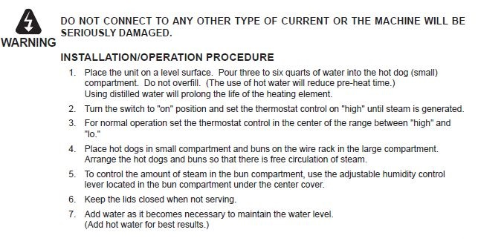

**1) SETUP**

Position the Hot Dog Steamer on a flat, level surface. Choose a sturdy, stable indoors location to place the hot dog machine. Machine should have plenty of

room for ventilation on all sides. Place the machine with the controls facing the operator. Plug the

machine in using the grounded cord attached to the machine. (Be careful to protect surface from

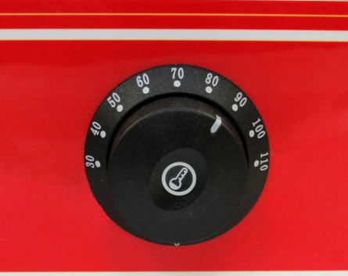steam.)

**2)Controls**

ON/OFF SWITCH - Turns on the machine by supplying power to the heat element.

HEAT CONTROL: By Adjusting the knob up or down, the heat control will adjust

the temperature of the steamer.

**3) PREPARING THE STEAMER**

Pour three to six quarts of water into the hot dog compartment (Distilled water is preferred) to the water pan. Use of hot water will reduce pre-heating time. Do not overfill.

DO NOT fill above the ledge as the cabinet will leak and the hot dogs will be sitting in water.

**4.TURNING ON**

Turn the switch to "on" position and ensure the LED light on the unit is illuminated

***If this is not the case please check the water float switch inside the tank (bottom right hand corner) and pull up to make contact and LED should come on***

Set the thermostat to "high" until steam is generated. Wait approximately 30minutes for the steamer to produce steam. Thermostat control in the center of the range between "high" and "lo." Add water as it becomes necessary for best results. **WARNING: Never allow the unit to boil dry.**

**5) OPERATION**

Place hot dogs in small compartment and buns in the top mesh rack in the large compartment. Arrange the hotdogs and buns so that there is free circulation of steam. Keep the lids closed when not serving.

Lift up the top or open the front glass door (depending on unit) and line the top and/or bottom

shelves with 3-4 rows of stacked, Buns. Stacking the hotdogs in the water until cooked and in steamer to keep warm (To speed warming and serving time, pre-cook hotdogs before placing in steamer.)

**6) SERVE**

After buns are warmed and hotdogs are also (10-15 minutes) serve hot dogs by opening the 2 doors and using the thongs and gloves (where applicable) place a bun on the napkins provided and add sausage to bun. Choose whether to allow customer to apply own sauce or not (usually self-service table provided)

**7) BREAKDOWN AND CLEANUP /** **AFTER USE:**

Just a few minutes work can save you from cleaning charges later! When finished, unplug machine, remove all food, and empty any remaining water.

You may wipe down but do not use any cleaning products when it is time to clean up, first make sure the machine is unplugged Turn off power and unplug machine.

Remove any remaining hot dogs and buns and drain the water through the drain pipe and allow unit to cool.

**8)CLEANUP**

Thoroughly wipe clean the entire unit, dry, and carefully ensuring unit is cool.

Wipe up juices collected on the front lip with paper towels and discard. Wipe up any other obvious grease or juices.

Clean the bun tray, partition, and the glass panels.

It is not necessary to clean under the drive frame prior to returning the unit after rental. **DO NOT** take this machine apart for any reason.

**There is an additional €20 cleaning charge for machines that have not been wiped down or emptied.**

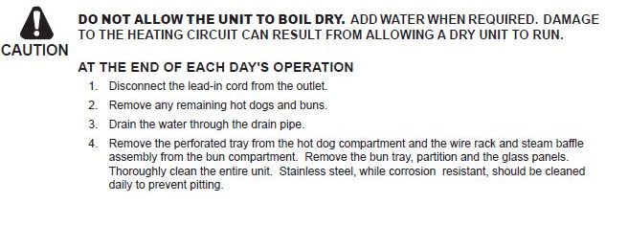**Caution**

**Tips:**

The machine can take up to 30min to boil a full load of hot dogs, to speed up the process pour hot water instead of cold.

Hot Dogs are precooked and only need warming for a couple of mins

You may consider leaving the hot dog buns in their plastic bag until ready to be served to prevent them from absorbing to much steam and becoming soggy.

Once the hot dogs are fully cooked, lower the temperature setting to prevent overcooking.

**NOTES**

Any other queries please do not hesitate to contact

085-2222000 or 0851020175

See video link here :

<https://www.youtube.com/watch?v=3BPgO9wDh64>