**Vevor Candy Floss Machine**

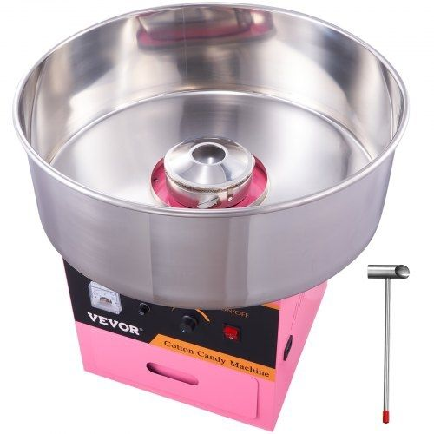

Thank you for renting a Candy Floss machine from PartyZone.ie. Please follow the directions below for to make delicious Ice cream for your event. If you have any questions or problems, please do not hesitate to contact us on 0852222000 or 0851568667.

**PLEASE READ ALL INSTRUCTIONS BEFORE USE**

**PRECAUTIONS**

Carefully read all instructions before operation.

Do NOT immerse any part of this equipment in water.

Keep cord and plug off the ground and away from moisture. Always unplug the equipment before cleaning.

To avoid burns, do NOT touch heated surfaces.

Do NOT place or leave objects in contact with heated surfaces.

Do NOT allow direct contact of this equipment by the public, this machine is NOT to be operated by anyone under the age of 18.

**Operating the Machine:**

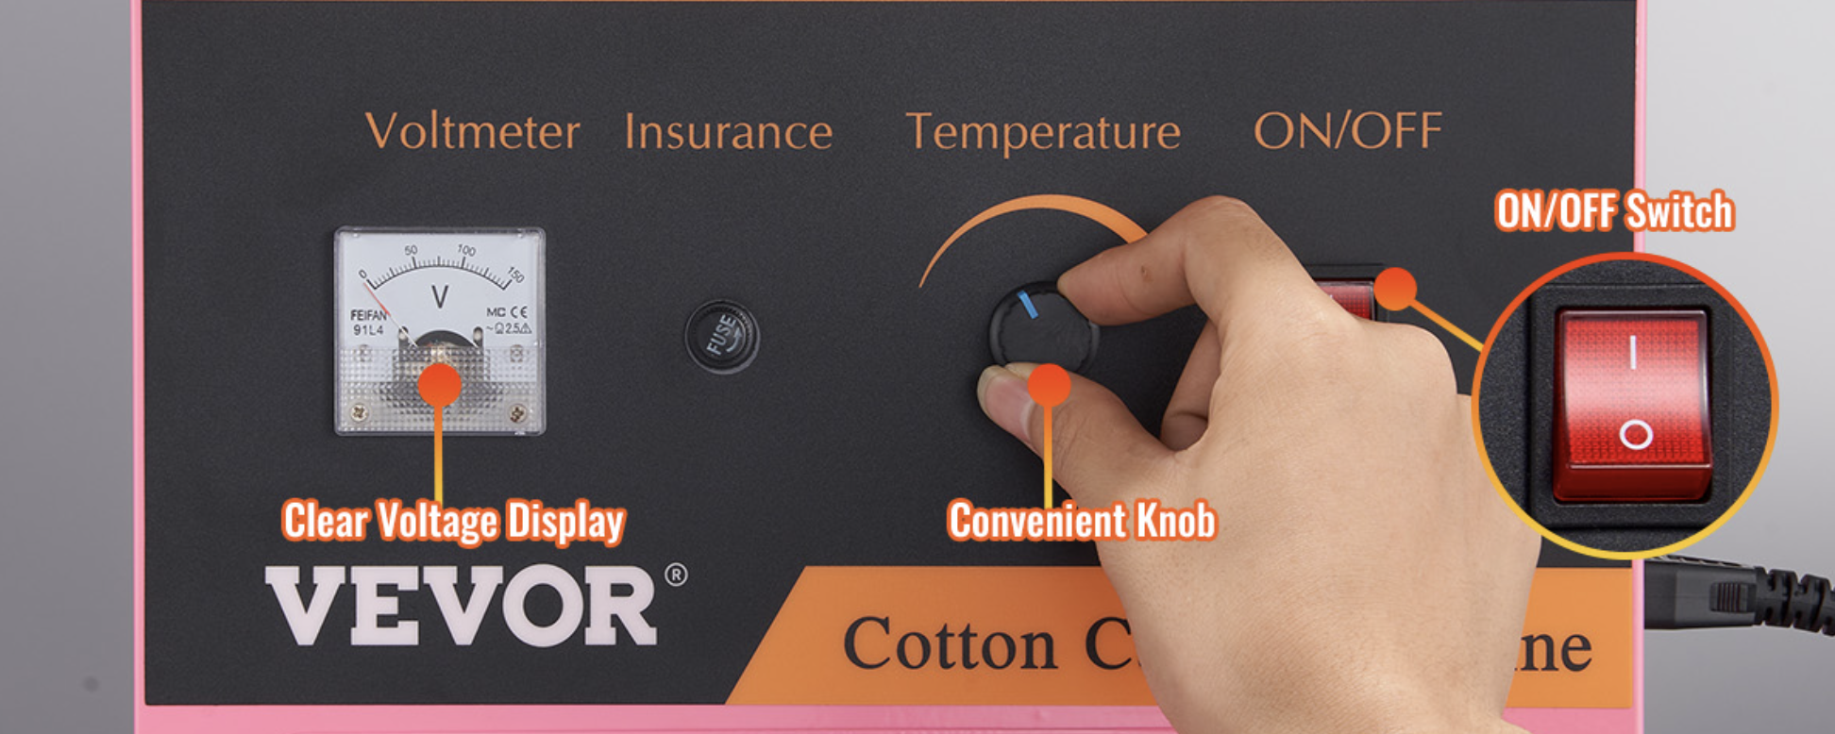

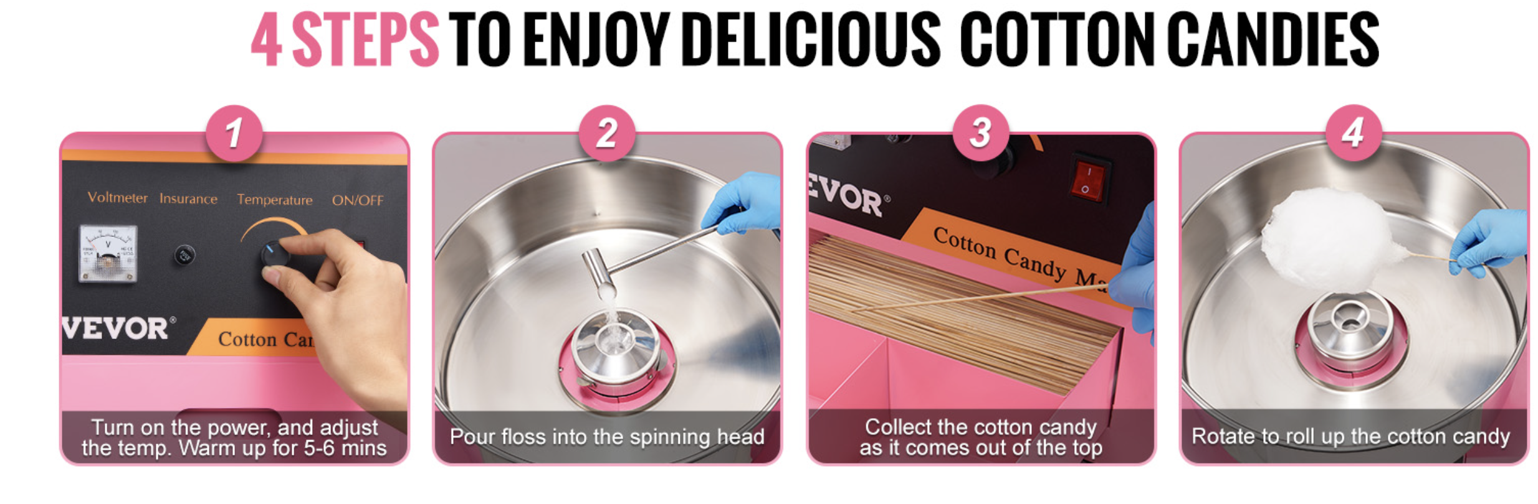

1. Press the switch to turn on the machine and wait for 1-2 minutes. Observe whether the machine runs smoothly when the spinning head of the machine is rotating. If the vibration is too severe, the machine needs to be adjusted. It must be ensured that the machine is placed stably.

2. Adjust the voltage knob to Max, and the voltmeter will change with the adjustment. Warm up the machine for 2-3 minutes. After preheating, the voltage can be adjusted according to the user's temperature requirements.

3. First, pour half a teaspoon of sugar, test the degree of heating and sugar production. When everything is okay, then pour a spoonful of clean white sugar in the center of the sugar head.

4. After about 3 seconds, the cotton candy starts to squirt out. Take a bamboo stick and rotate it a few times along the inner wall of the bowl. Then, place the stick horizontally and rotate it over the spinning head to form cotton candy. Different shapes can be made by tilting the sticks.

5. After making enough cotton candy, turn off the machine.

**Making Floss:**

1. Keep hands away from spinning head!

2. Pick a cone; if it sticks in the stack of cones, twist it off the stack.

3. Hold an inch or two of the pointed end of the cone between two fingers and a thumb. With a light flicking action, roll cone in the web of floss building

up in the pan. Lift the cone up with the ring of floss attached and rotate the cone to wrap the floss. DO NOT roll floss while the cone is inside the pan. This

will pack the floss too tightly.

4. If the floss fails to stick to the cone, pass the cone near the spinner head to pick up a “starter” of melted sugar. Lift the cone out of the pan and

wrap the floss with a “figure eight” movement of the hand. This leaves giant pockets and makes the final product appear larger.

5. Make sure room humidity is not too high, or product will be “heavy.”

6. In operation, the floss will collect on the mesh stabilizer inside the bowl. If the floss collects “low” on the netting, twist the front (leading) edge of the

leather floaters down. You get more lift and the floss will collect higher.

Cleaning the Machine:

1. The machine needs to be cleaned after the cotton candy is made, otherwise the spinning head may be blocked. Keep the machine running during the cleaning process, pour a small amount of water into the rotor, then the rotor will shake off the water slowly. After that, turn off the machine and clean it with a dry soft cloth.

2. If the spinning head is blocked, turn off the machine and open the spinning head, then clean up the burnt sugar.

3. Do not wash the machine with detergents such as washing powder.

4. Do not rinse the machine directly with water.

|  |
| --- |
|  |

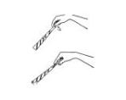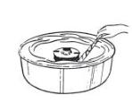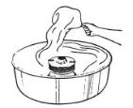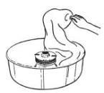

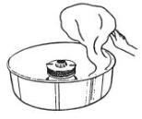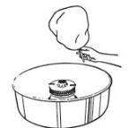

**Warnings**

1. Make sure the machine is properly grounded.

Disconnect power before cleaning, servicing or removing any covers.

This unit is to be serviced by qualified personnel only.

1. Moving parts can crush or cut. Keep clear of the spinner's head. Allow

spinner head to stop before loading with sugar.

1. Risk of eye injury.

Wear eye protection. DO NOT operate without a shield or screen

between cotton candy bowl and customer.

◻ Burn Hazard

Do not touch the spinner's head. Allow it to cool before cleaning or servicing.

◻ Unit not to be operated by anyone under the age of 18

TroubleShooting

Fault: No Sugar Filament

1. Check whether the sugar head is rotating or not and stop the machine to sense whether the sugar head is hot. 2. If the sugar head does not rotate check whether the machine is powered on, and whether the motor is broken.

3. If the sugar head is not hot: check whether the machine is powered on, whether the sugar head is ringing, and whether the voltage is excessive.

4. Unscrew the fuse knob on the panel or pry open the fuse cover (for Countertop Type) in the socket, then, take the fuse out to check whether it is burnt out.

5. Remove the baffle & upper cover and take out the cover through the spinning head, then you can see the internal condition of the machine. Check whether the carbon brush is loose or not working, if so, replace it with a new one.

There is an additional €20 cleaning charge for machines that have not been wiped down or emptied.

**NOTES**

Any other queries please do not hesitate to contact

085-2222000 or 085 156 8667

<https://www.youtube.com/watch?v=qPp4pR7_5ho>

<https://www.youtube.com/watch?v=dsuf7lt26Cg> – mayo one instructions