**Operating Manual**

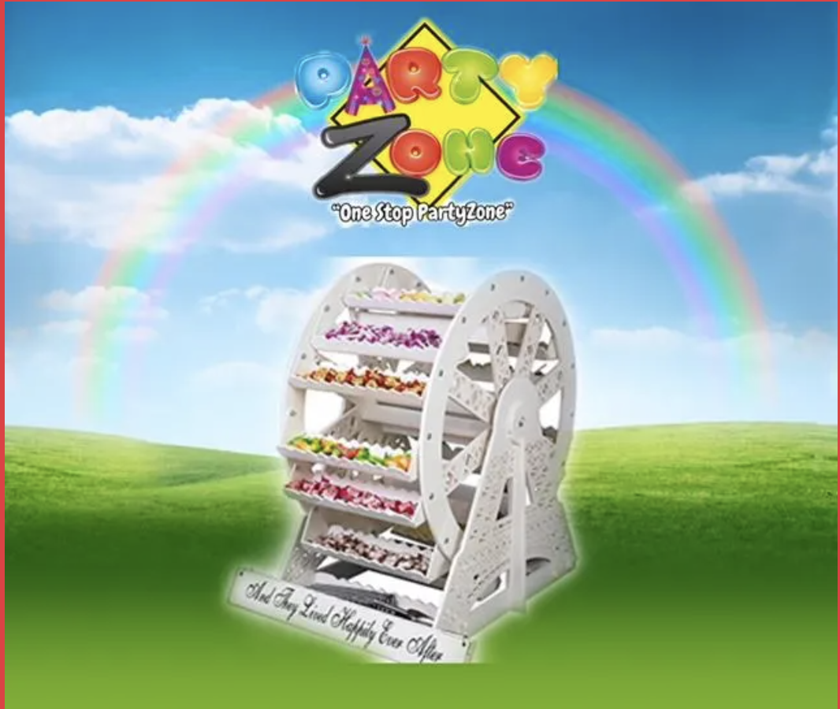

**CANDY FERRIS WHEEL CONSTRUCTION INSTRUCTIONS**

Thank you for renting our Slush Puppy machine from PartyZone.ie. Please follow the directions below to make delicious slush puppies for your event. If you have any questions or problems, please do not hesitate to contact us on 0852222000 or 0851568667.

**PLEASE READ ALL INSTRUCTIONS BEFORE USE**

**PRECAUTIONS**

Carefully read all instructions before operation.

Do NOT immerse any part of this equipment in water.

Keep cord and plug off the ground and away from moisture. Always unplug the equipment before cleaning.

To avoid burns, do NOT touch heated surfaces.

Do NOT place or leave objects in contact with heated surfaces.

Do NOT allow direct contact of this equipment by the public, this machine is NOT to be operated by anyone under the age of 18.

**Electrical Specifications:**

**Make sure to plug in to a dedicated line with the specifications above and that no other appliances are on the same circuit.**

**Parts**

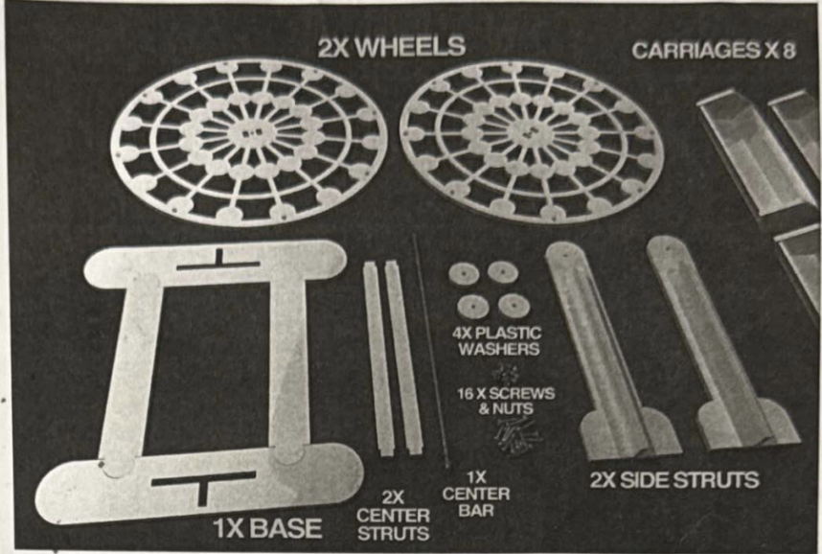

1. Slot the Side struts into base
   1. Might take a little force to slot in.
   2. Make sure that the struts are level with base from the underside when pushed.

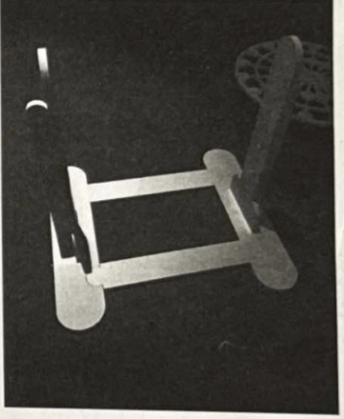

1. Slot the Center Struts into Wheel
   1. Ensure wider hole side on wheel are facing outwards this may take a little pressure to slot in to ensure tight fit.

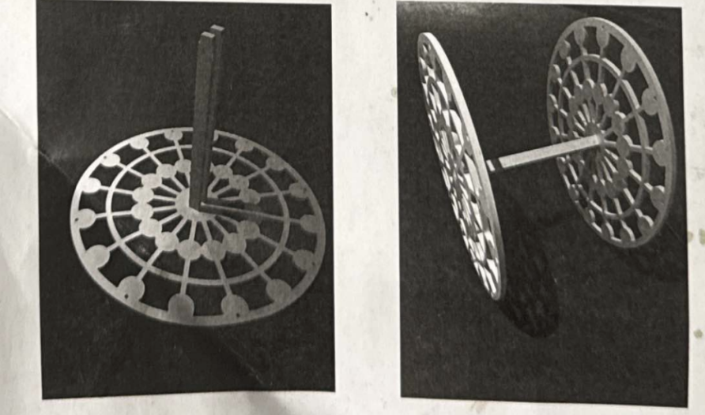

1. Fit the Center Bar
   1. Through 1 washer, then the side strut, then another washer then wheels and repeat for the other side and add nut at the end. The larger Washer goes next to the wheel.

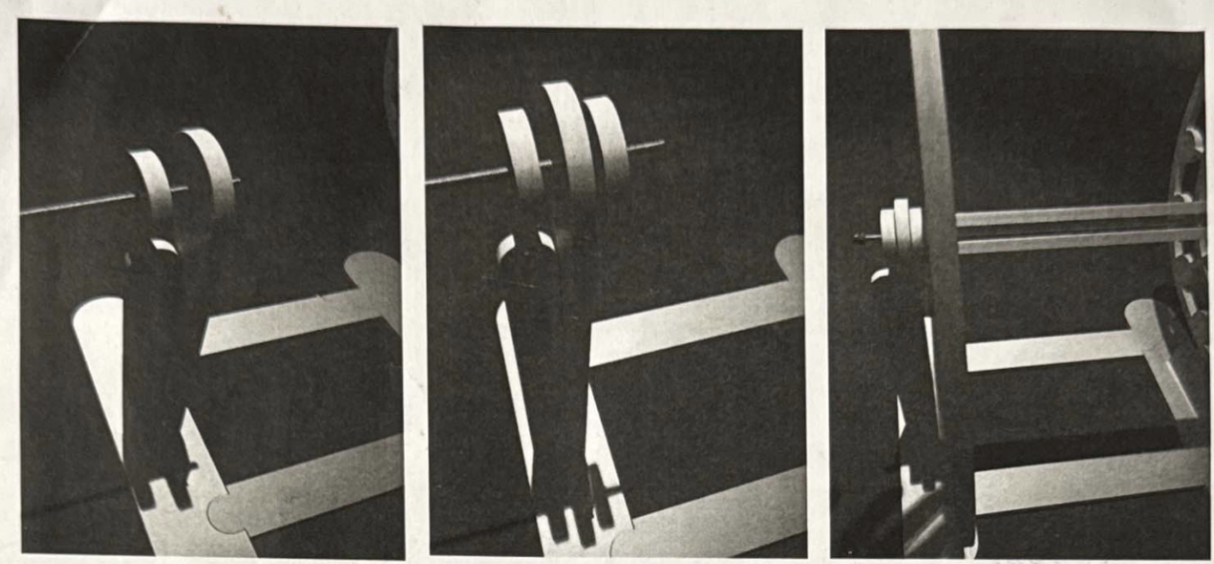

1. Finally Add the Carriages
   1. With screw heads sinking into wheel outer and nuts on the inside- As shown below:

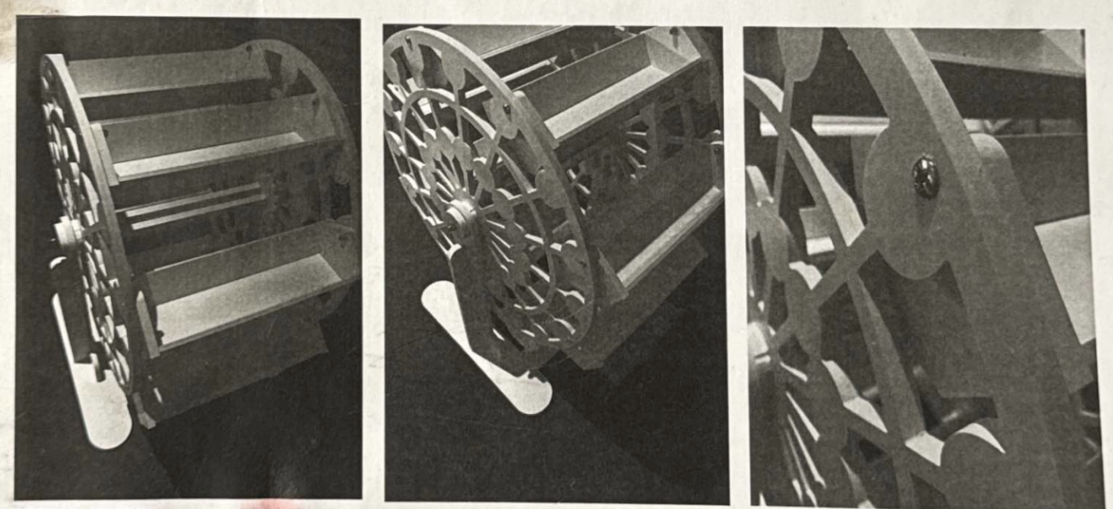

Please Note:

Make sure all parts are firmly in position and center bar screws are fairly tight. No gaps no joins of all parts. This will ensure sturdy movement of your wheel. If parts are loose or incorrectly positioned- the wheel will feel loose and will not turn as easily.

Please clean your Ferris wheel using wet wipes, this will remove dust, grime and any loose material. This material is completely waterproof and cleanable. It is not dishwasher proof as heat will affect the material. It can be rinsed in cold-warm water with the mildest cleaners.

**Carriage Construction Instructions**

Parts:

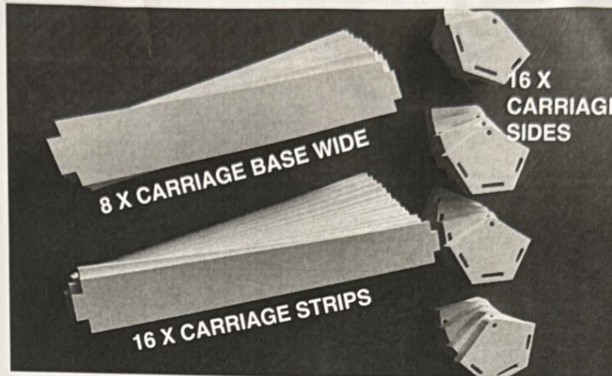

1. **Slot the Carriage Wide Base Strip into the Carriage Side**
   1. It may take a little bit of force to slot in. Please ensure that it is firmly pushed all the way and there are no gaps.

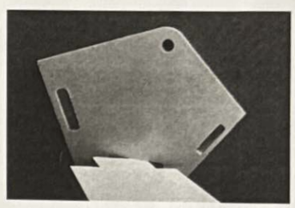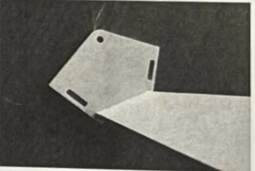

1. **Slot 2 x Carriage Strips into the Carriage Sides**
   1. It may take a little bit of force to slot in. Please ensure that it is firmly pushed all the way and there are no gaps.

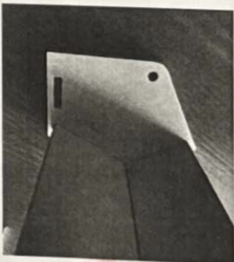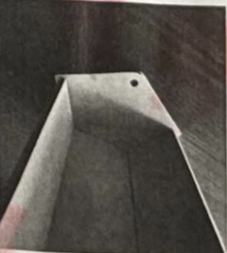

1. **Turn the Carriage Around and Align Slots into Strips**
   1. It may take a little bit of force to slot in. Please ensure that it is firmly pushed all the way and there are no gaps.
   2. You can tap lightly with your palm- this will make it easier to slot in nicely.

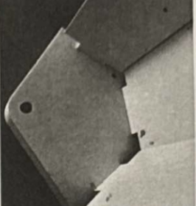

1. **Gently Push the Carriage Strips Firmly into the Carriage Sides**
   1. It may take a little bit of force to slot in. Please ensure that it is firmly pushed all the way and there are no gaps.

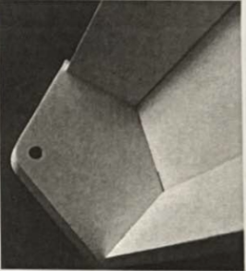

1. **Your Carriage Should Look Like This:**
   1. Please make sure there are no gaps.
   2. Please repeat for 8 carriages

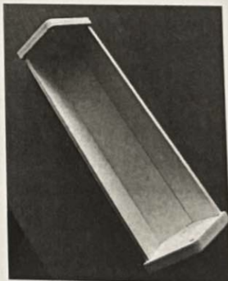

The Ferris Carriages are now complete!

**NOTES**

Any other queries please do not hesitate to contact

085-2222000 or 0851020175

www.PartyZone.ie